ClarkEfolio Training Manual for Faculty
Updated April 4, 2022

Introduction to ClarkEfolio
ClarkEfolio is a comprehensive system to record Clark faculty activities in the areas of Teaching, Research, and Service. ClarkEfolio provides a central location for faculty to record their achievements and eliminate data redundancy. With this electronic management, internal support units can obtain needed information to promote the work and scholarship of our faculty.
There is more information regarding ClarkEfolio on the Academic Affairs webpage here: https://www.clarku.edu/offices/academic-affairs/clarkefolio/

How to log in to ClarkEfolio
You can login to ClarkEfolio using your Clark credentials. Navigate to the ClarkYou portal and click on “ClarkEfolio” in the list on the left.
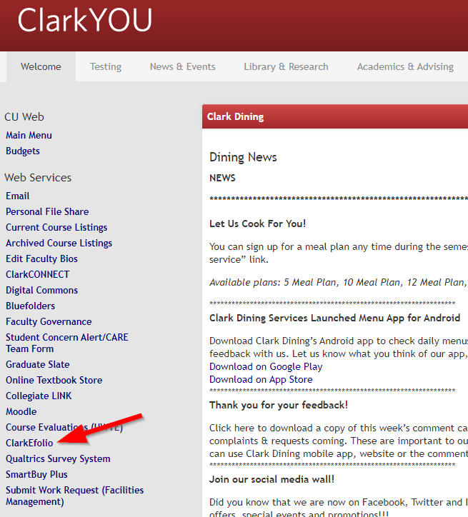

This will bring you to the ClarkEfolio page on the Academic Affairs website at https://www.clarku.edu/offices/academic-affairs/. (You can also bookmark this page in your browser.) The ClarkEfolio login button is in the middle of the page:

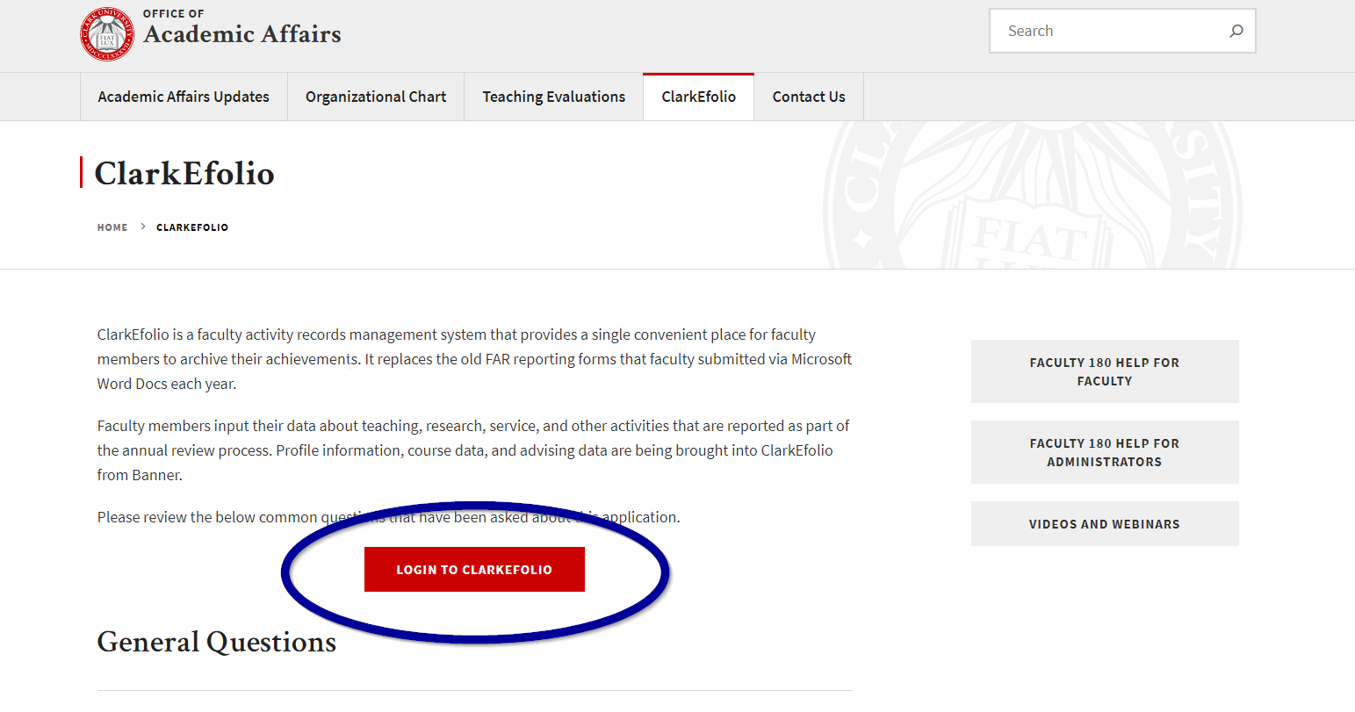

Dashboard
Once you log in to ClarkEfolio, you will see your Dashboard, or Home page. Your Dashboard should look similar to this:

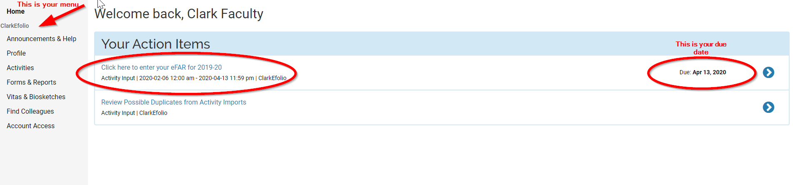

Any pending, or action, items will be available for access from the Dashboard. You can click on any of the links available to update the information requested. If you click the first item above, “Click here to enter your eFAR Activities for Summer 2021 – Spring 2022” you will be taken straight to the Activities Section (see Activities below) to update your FAR information for 2021-22. You can also click directly into the Announcements, Profile and Activities sections. Those are described below.

Quicklinks Tool

WHAT IS QUICKLINKS?
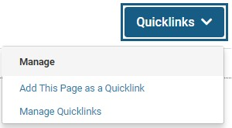
The “Quicklinks” button provides users with quick and easy access to the screens they use often. For example, if there is a report that is used on a regular basis, and it contains complex filters, the user might want to create a quick link to that report so it can be accessed quickly. Each user can create their own Quicklinks, which can be shared with other users if they choose.

While the Quicklinks button is not available on the homepage, you can still access to the tool from any ClarkEfolio specific page within the Interfolio product.
Click “Quicklinks” in the upper-right corner of the screen, then click “Add This Page as a Quicklink.” The Add Quicklink dialog box opens. A default name for the Quicklink displays. IF you choose, type a new name for the quick link in the “Name” field. When you are finished, click “Save.”

Announcements & Help
Under the “Announcements & Help” section you will be able to find the link to Clark’s ClarkEfolio webpage. We may also post announcements and answers to frequently asked questions there.

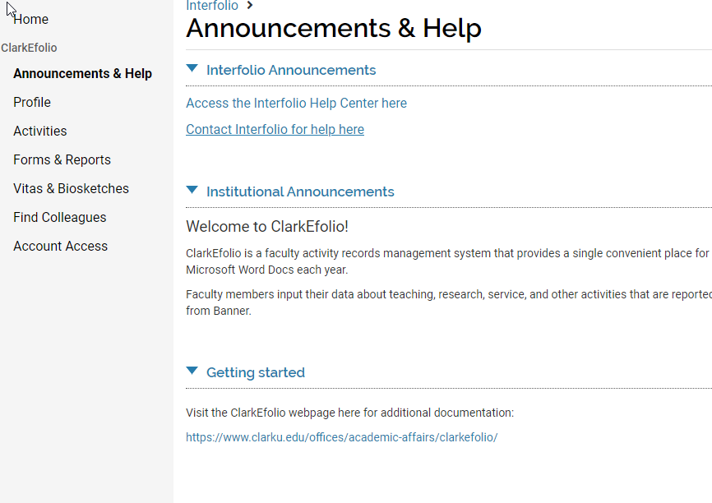

Profile
The information on the “Profile” section has standard information pertaining to yourself. See screenshot below.
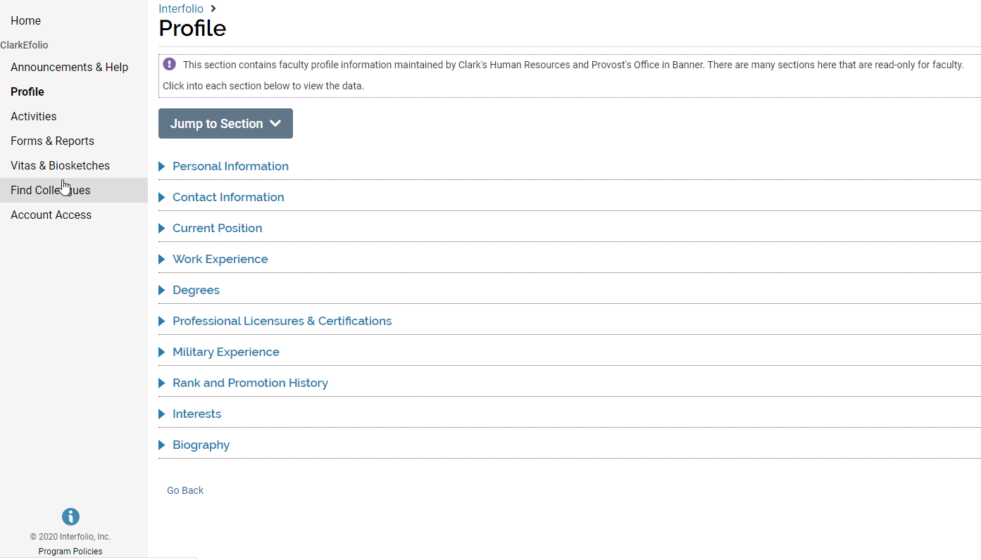
Many of the fields in the Profile section are locked and you cannot edit the information. These sections include:

Personal Information

Contact Information

Current Position

If you find incorrect information in any of these sections, please report it by emailing ClarkEfolio@clarku.edu.

Profile sections that you may want to update include:

Work Experience
There is no data here as of April 2022, but if you wish to use ClarkEfolio for maintaining your own CV, you may wish to enter some information in this section.

Degrees
This data was compiled by the Provost’s Office. If you wish to make any changes in this section, please email ClarkEfolio@clarku.edu.

Professional Licensures and Certifications
This section is optional and may not apply to everyone.

Military History
This section is optional.

Rank and Promotion History
There is no data here as of April 2022, but if you wish to use ClarkEfolio for maintaining your own CV, you may wish to enter some information in this section.

Interests in teaching, research, and service
The information you enter in this section is searched when you or your fellow faculty use the "Find Colleagues" functionality (located in the navigation on the left) to search for faculty with specific areas of interest. These include areas in which you identify yourself as an expert or areas in which you are interested in doing work.

Biography
A short statement (or “blurb”) about yourself, perhaps similar to what is on Clark’s website.
If you would like to add information, please select the “Add” button and a new screen will appear.
Write a brief biography (outlining, for example, education, work experience, publications, external funding received, creative works, contributions to the profession, professional associations and/or licenses, research interests, expertise). Your biography should be written in the third person format.
Click on the “Edit” button and a pop-up window will appear. Add your biography in the text box provided and click “Save.”

Activities
The Activities area will be the area you visit most frequently to update your research, teaching, and service activities. It is used to keep track of things like:
- Advising load at the undergraduate and graduate levels
- Information about students being supervised by the faculty member
- Professional and creative works that are pending and/or complete
- Pending grants and funded amounts
- Participation in standing committees, and similar service at other academic institutions and professional organizations
- Professional development, including conferences, training, and continuing education
- Professional consultation provided by the faculty member
Faculty members can update most of their activity information at any time. In addition, Clark will have annual Faculty Activity collection periods in the Spring of each year. Reminders that the Activity Input Form needs to be reviewed and submitted will be emailed to faculty.
To access your activities, please select “Activities” on the left-hand menu, or click on the related action item from the Home page, if available.
Here is a list of all the sections under Activities. They are grouped into three sections: Research, Teaching, and Service.
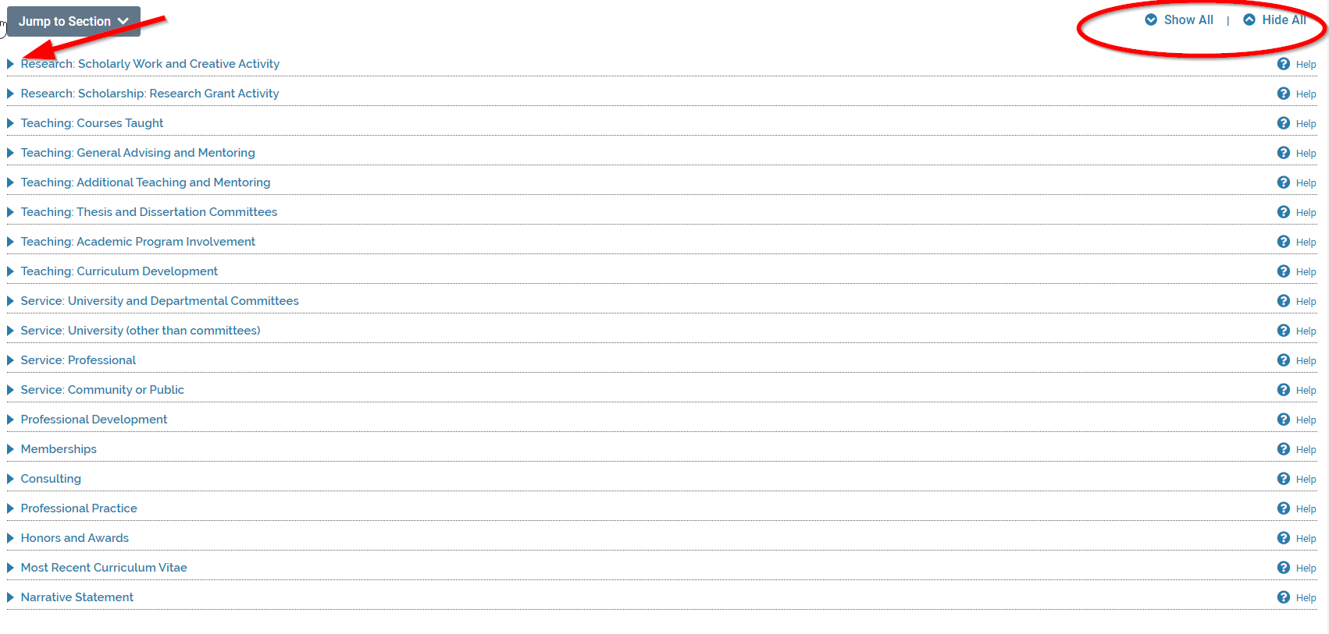

Use the blue triangles at the front of each section to open that section. You can also use the “Show All” and “Hide All” links in the top right corner to expand and collapse all of the sections at once.
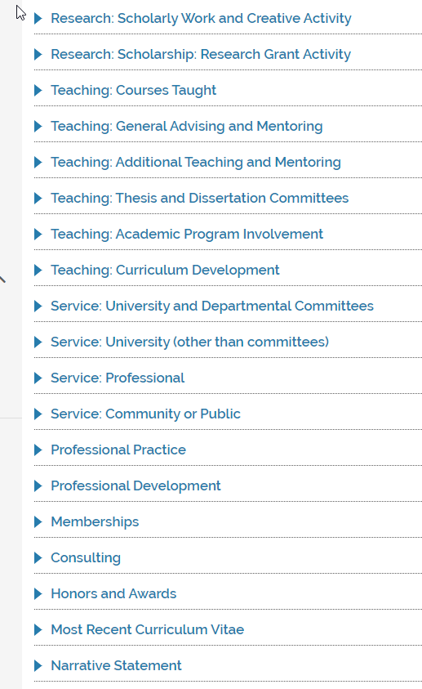

NOTE: New as of 2020-21

We created two new Activity Classifications in 2021 to track Community Engagement and Diversity, Equity, and Inclusion efforts. They are listed under many of the Activity options. If your activity falls under one of these two classifications, please select “Yes” to mark it as such.

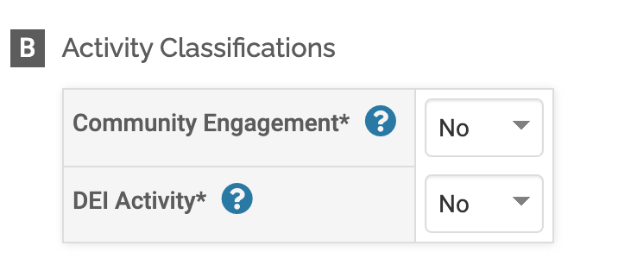

Research: Scholarly Work and Creative Activity

The “Scholarly Work and Creative Activity” section is used to view and enter activities relating to scholarly or professional works (e.g., journal articles, books, proceedings) and creative works (e.g., performances, exhibitions) that you are participating in or have completed.

You can edit, delete, or clone Activities by using the “Actions” icons on the right side of the page:

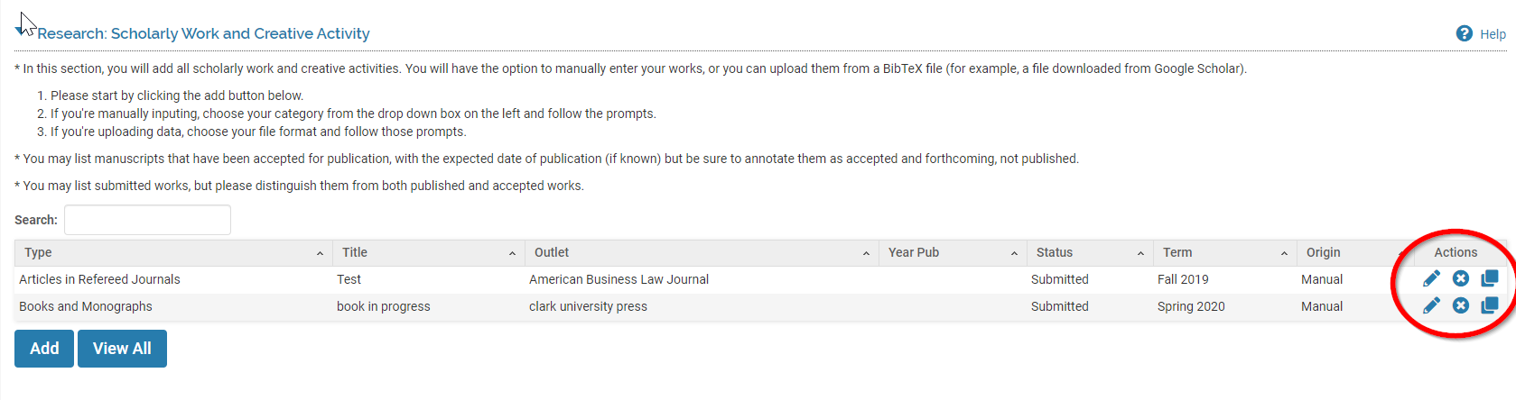
Use the “edit” icon to update the status of an activity that was previously entered. If you have a recurring activity, you may choose to use the “clone” functionality to copy the activity and create a new one for a new time period.
If you would like to add information, please select the “Add” button and a new screen will appear.
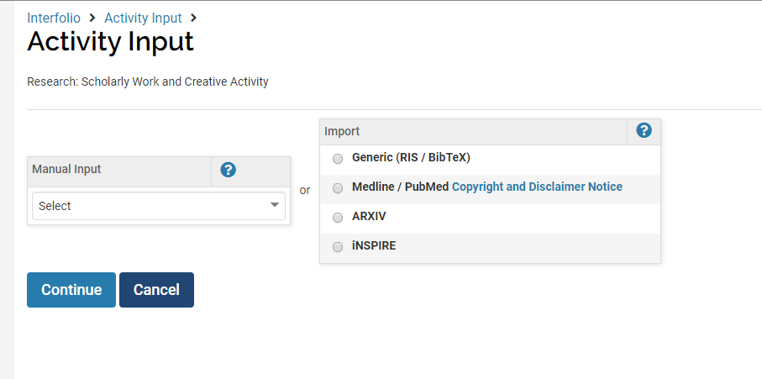

When adding a new activity, you have the option of entering data manually or importing citations from publications. If you want to Import your scholarly activities from an RIS or BibTeX file, the Clark Library has created a one-page resource that may be helpful to you, available on our website: http://www.clarku.edu/offices/academic-affairs/wp-content/blogs.dir/3/files/sites/61/2020/02/RIS_Citation_Capture_Clark_eFolio.pdf
If you have any publications populated in the Google Scholar data system, the easiest way to upload all the files into ClarkEfolio will be as a “Generic BibTeX” when you are adding a scholarly activity. You can upload as a file or as text.
In order to upload this data, click on “Activities” from the main menu on the left-hand side. Then, click to add a Scholarly Publication. Select to import a “Generic (RIS/BibTeX),” and click continue.
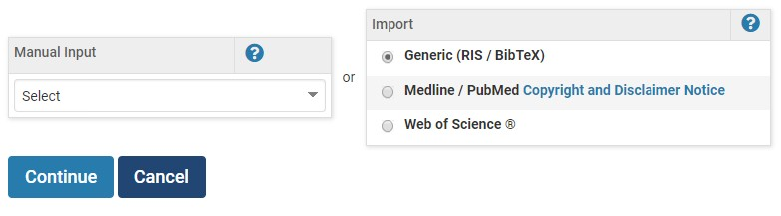
This will take you to the importing page where you will select the format and the citation data.

You can import using either RIS or BibTeX formats. Select the correct format and you can upload a file or copy and paste the information.
To copy and paste the information, select the option for “Copied Text” and paste the information on the textbox. When you are finished, click the “Save” button.
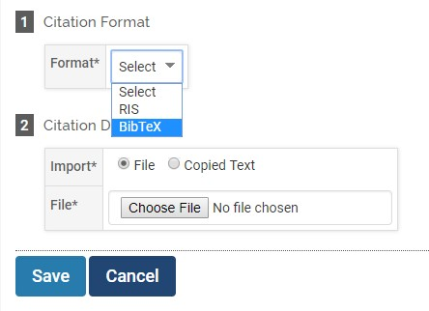
To upload a file, select the “File” option and click on “Choose File.” Select the correct file and click the “Save” button.

To input information manually, from the drop-down menu select the type of activity you would like to add.
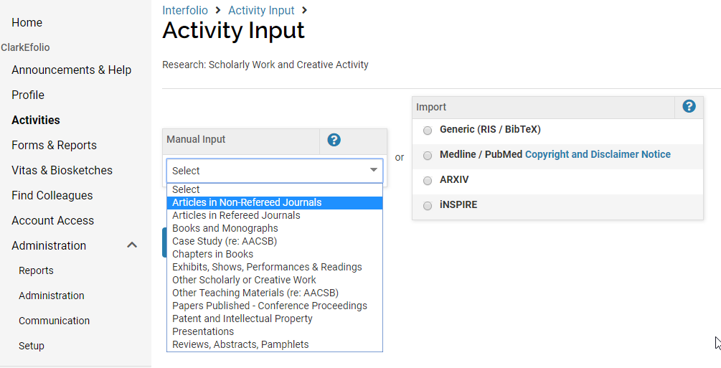
Your options are:
- Articles in Non-Refereed Journals
- Articles in Refereed Journals
- Books and Monographs
- Case Study (for AACSB collection and reporting)
- Chapters in Books
- Exhibits, Shows, Performances and Readings
- Other Media (social media, blogs, podcasts, etc)
- Other Scholarly or Creative Work
- Other Teaching Materials (for AACSB collection and reporting)
- Papers Published- Conference Proceedings
- Patent and Intellectual Property
- Presentations
- Reviews, Abstracts, Pamphlets
Choose which type of scholarly work or creative activity best represents your work and click on the “Continue” button. A new screen will appear. Complete the form shown on your screen.
Please note that all fields marked with an asterisk (*) are required to be completed. You must indicate a “Status” and a “term” and “year” at the top of each form. You can indicate the status of an activity as “in progress”, and then at another time in the year (or next year) you can edit that item’s status (see screenshot below.) You also need to select a term and a year. This will allow us to pull in this activity when we query for certain terms to populate each year’s Faculty Activity Report. You may add an attachment if you wish, but it is not required.

Once you complete the form, select “Save and Go Back” in order to return to the previous screen. If you’d like to add any other information, you may click on “Save and Add Another.”

Research: Scholarship: Research Grant Activity

This section can is used to add pending grant-related projects, proposals, awards, and renewals. You may enter any information in grants which you have or are currently working on. Funding amounts should also be updated to reflect ongoing changes and maintain a complete history of the project throughout its completion. Funding dates can be recalculated based upon the start date and grant periods.
You can use the edit, delete or clone Actions on the right side of the page, or click “add” to add a new grant item.
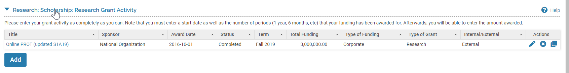

After you click add, a form will appear for you to complete. Please enter a status, semester, year, and grant title, as well as any other information that have currently. Please enter your grant activity as completely as you can. Note that you must enter a start date as well as the number of periods (1 year, 6 months, etc.) that your funding has been awarded for. Afterwards, you will be able to enter the amount awarded.

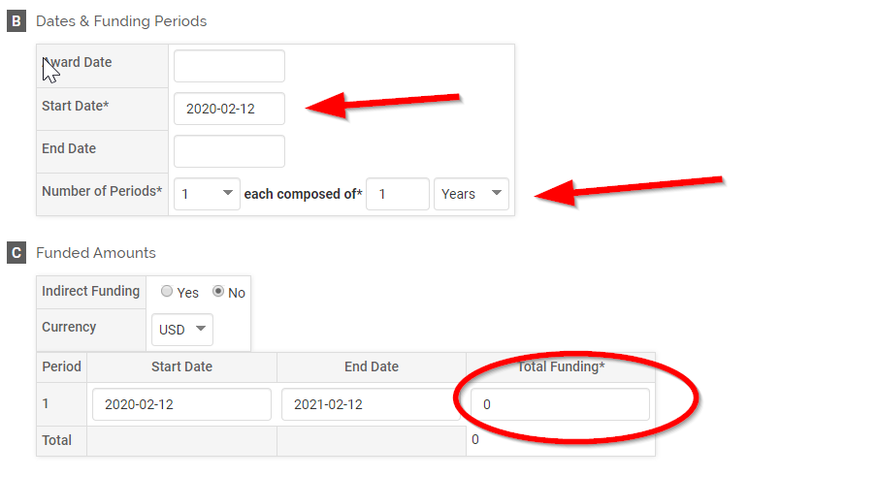

Please note that all fields marked with an asterisk (*) are required to be completed. Once you complete the form, select “Save and Go Back” in order to return to the previous screen. If you’d like to add any other information, you may click on “Save and Add Another.”

Teaching: Courses Taught

In the “Courses Taught” section, you will be able to see all the courses that you have instructed by clicking on the “View Teaching” button. This data has been imported from Banner. If you have any questions about the courses in this section, please email ClarkEfolio@clarku.edu.

A new screen will appear where you can select the semesters for which you want to view the courses in which you have taught and click the “Refresh” button.
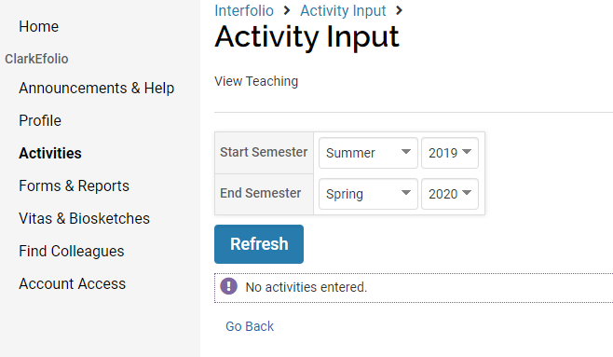
Scroll down and you will see a breakdown, by semester, of the courses. You will not be able to edit these courses as they are pulled directly from Banner. However, you can add any course attachments such as the course syllabus, course evaluation, etc. To add any additional attachments, click on the “Add” button and a pop-up window will show.
Once you have selected any files and filled out the form, click on “Upload” and the files will be added to the specific course.
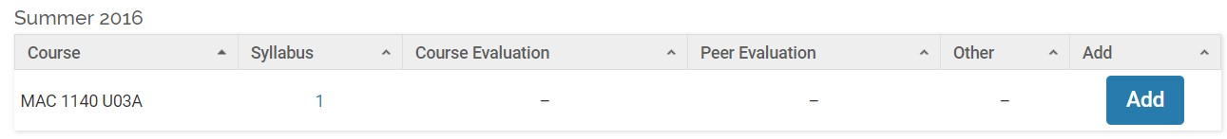
To delete a course attachment, click the attachment type you wish to delete for the desired course, click the
“Delete”

icon, the click “Delete.” The course attachment is removed.

TEACHING: General Advising and Mentoring
The information in this section is pulled in from Banner. Please do not make any changes to this data, as your changes may be lost the next time we update from Banner. If you have any questions about your numbers of advisees, please email ClarkEfolio@clarku.edu. Your data could look something like this:
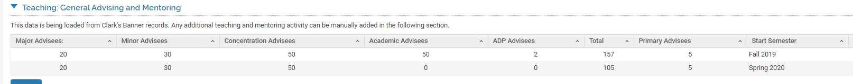

Teaching: Additional Teaching and Mentoring

This section is used to enter any additional teaching and mentoring activities that were not included in the previous section. This includes any of the following types of activities:
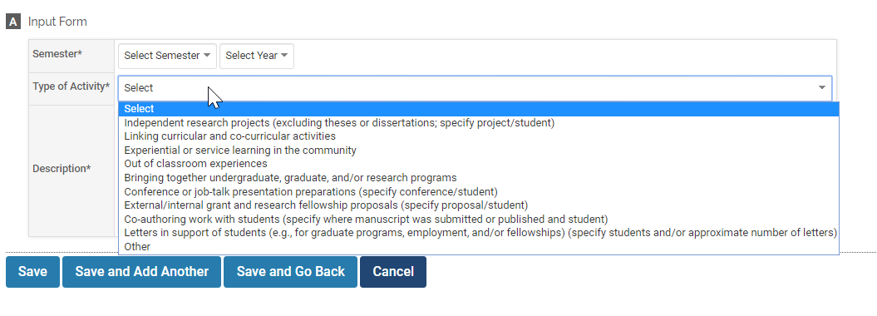

Teaching: Thesis and Dissertation Committees

Use this form to add information about the thesis and dissertation committees you’ve served on. The form includes the following fields:
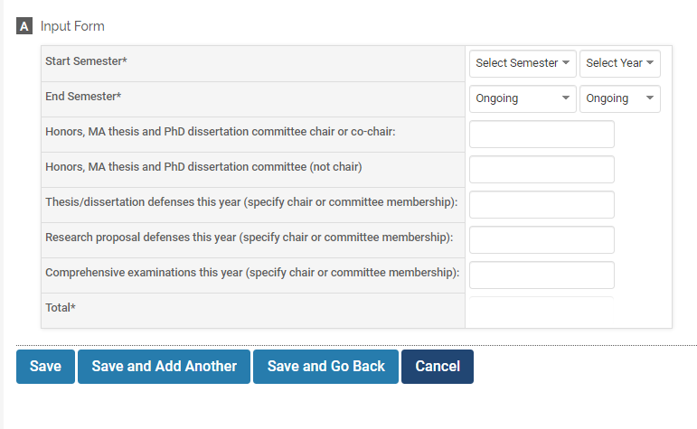

Teaching: Academic Program Involvement
Use this section to describe any involvement in departmental and interdisciplinary programs outside of your home department. For those programs in which you have had major involvement this year, your department chair will seek input from the program chair as part of your end of year review (please be sure to designate these areas of major involvement).

Teaching: Curriculum Development
Describe your work to create new courses and/or modify existing courses to keep up with changes in your discipline, strengthen undergraduate programs, and/or enhance the attractiveness of Clark to current and prospective undergraduate students (please describe in a few sentences the changes made).

Service: University and Departmental Committees
This section reports both University-level and Department-level committee participation. If you would like to add information, please select the “Add” button and a new screen will appear. Complete the form on your screen.
The major University-level committees have been pre-populated so you can choose one. You can also choose “other” if you don’t see the name of your committee.
To enter a Departmental-level committee, click the blue “change” button in the Unit section (see screenshot below) and you will be able to scroll down to the correct department.
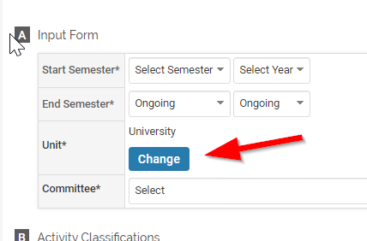
And then choose your department…
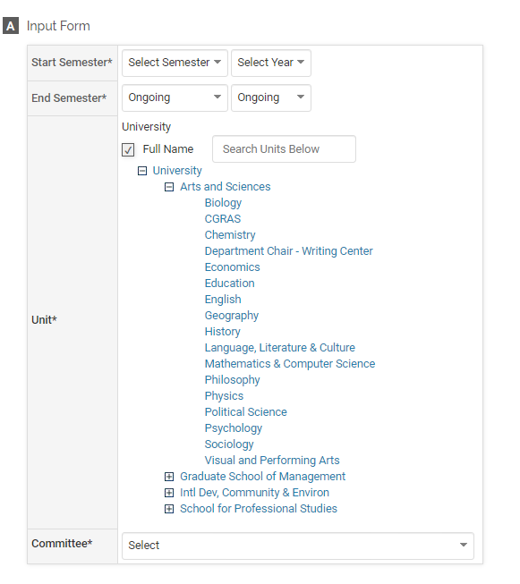
Some Departmental-level committees are pre-populated. If your committee is not shown, choose “other” and enter the committee name.

Please note that all fields marked with an asterisk (*) are required to be completed. Once you complete the form, select “Save and Go Back” to return to the previous screen. If you’d like to add any other committee information, you may click on “Save and Add Another.”

Service: University (other than committees)
This section includes all other types of service to the University, such as:
- Central administration posts
- Departmental chair or director (or associate chair or director) posts
- Interdisciplinary concentration coordinator posts
- Departmental track coordinator posts
- Faculty/Peer mentoring
- University committees for which you stood for election
- Participation in UG admissions open houses and events (e.g., presidential scholars) and/or conducting general interviews with UG applicants or visitors (non-departmentally specific)
- On-campus and off-campus alumni events and/or trustee activities
- Co-curricular and extracurricular engagement with student life (e.g., student clubs, sports teams, participation in special events)
- Participation in fund-raising activities
- Developing local or global partnerships for Clark (e.g., a foreign study program, student exchange program) or evaluation of existing partnerships
- Contributing to grant proposals in support of University programs
- Other departmental and interdepartmental service
- Other University-wide service
As in the previous section, you can choose to enter activities at the University level or the Department level.
REMEMBER: In any Activity section, you can edit, delete, or clone Activities by using the “Actions” icons on the right side of the page. This can save you time!

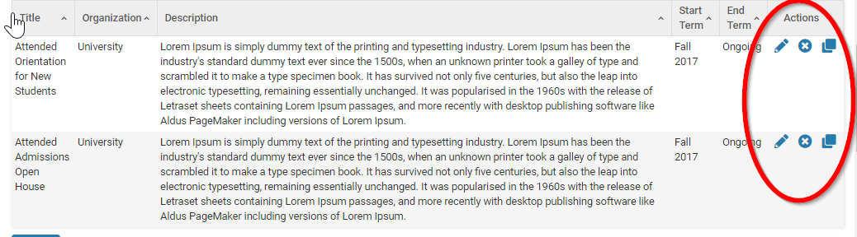

Use the “edit” icon to update the status of an activity that was previously entered. If you have a recurring activity, you may choose to use the “clone” functionality to copy the activity and create a new one for a new time period.

Service: Professional
Use this section to report:
- Offices held in professional societies or organization
- Editorial boards or refereeing positions
- Reviewing tenure and promotion cases for peer institutions
- Other professional service (please specify)

Service: Community or Public
This includes community or public service beyond but related to the University. This could include service in support of the Worcester community or that which increases the visibility of Clark regionally, nationally, or globally. Including, but not limited to the following:
- Talking to the media (e.g., for newspaper articles, radio/TV programs)
- Offering professional expertise or advice to the general public (e.g., giving a presentation to a business, school group, or government officials; responding to queries from individuals outside academia)
- Serving on the boards of local, state, or national groups
- Testifying at public hearings
- Community advocacy and partnership building work
- Other community or public service (please specify)

Professional Development
The “Professional Development” section is used to add any conferences, training, continuing professional education, etc. in which you participated. Do not list degrees in progress in this section. Degrees are entered in the Profile Form under “Education.”

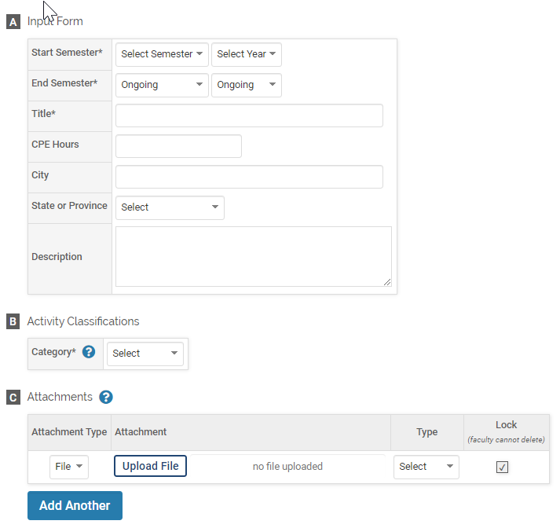

Memberships
Use this section to report memberships (not leadership positions) in academic and discipline-specific organizations.

Consulting
If you engage in formal consulting work outside of Clark that is related to your academic appointment, add that here. If you provided consulting services as a professional, input the information under this section. This is may apply to Professors and Associate Professors of Practice.
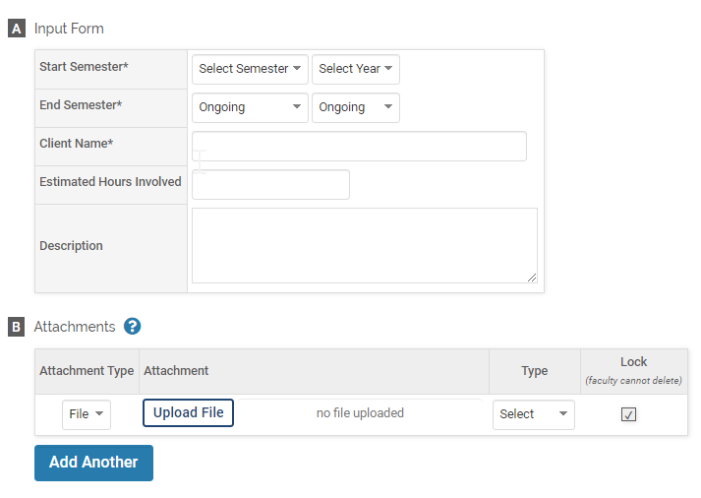

Professional Practice
As with the previous section, this section applies to faculty members (especially, but not limited to, Professors of Practice) who augment their work as academic scholars with activities that involve substantive linkages to practice and other forms of professional engagement. If you’ve already entered a formal consulting engagement in the previous section, do not enter it again here.
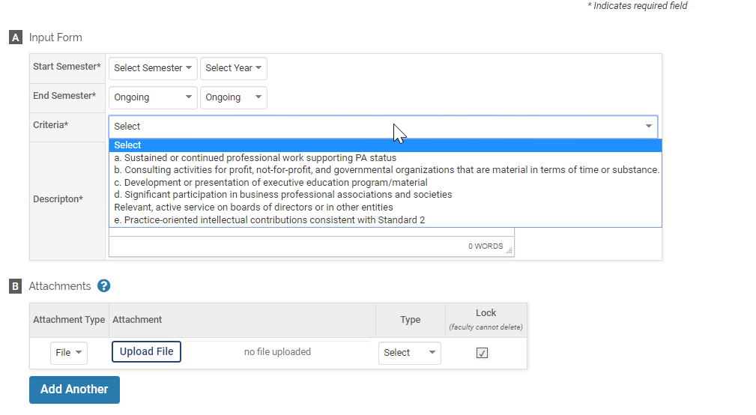

Honors and Awards
Use this Honors and Awards section in your Profile to report honors and awards received.
If you would like to add information, please select the “Add” button and a new screen will appear. Complete the form on your screen.
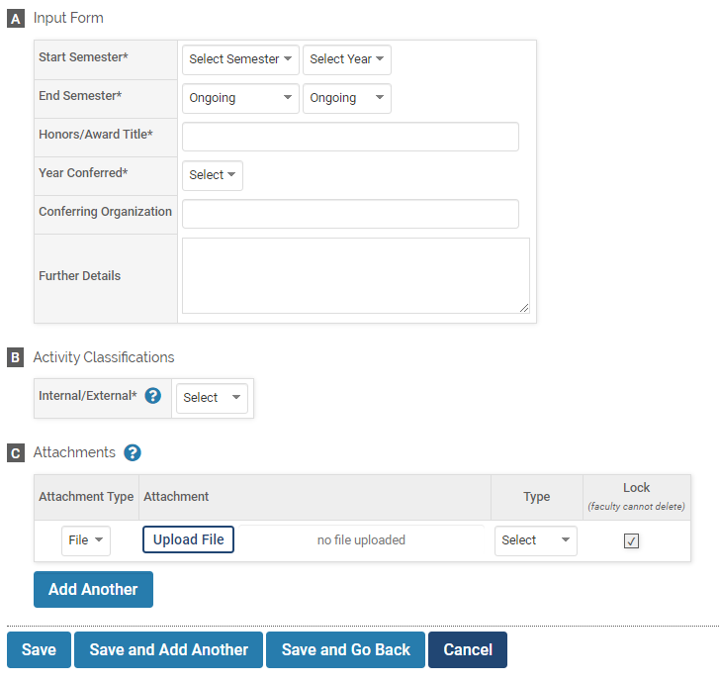

Most Recent Curriculum Vitae
If you have an up-to-date copy of your CV, upload it here.

Narrative Statement
In this section, you may enter additional comments for each area of activities: Teaching, Research/Scholarship, and Service. You should also share your goals for the academic year and ways to measure the outcome for these goals. Goals entered will be picked up in the annual evaluation (FAR) as it relates to the dates selected.
If you would like to add information, please select the “Add” button and a new screen will appear. Complete the form on your screen.
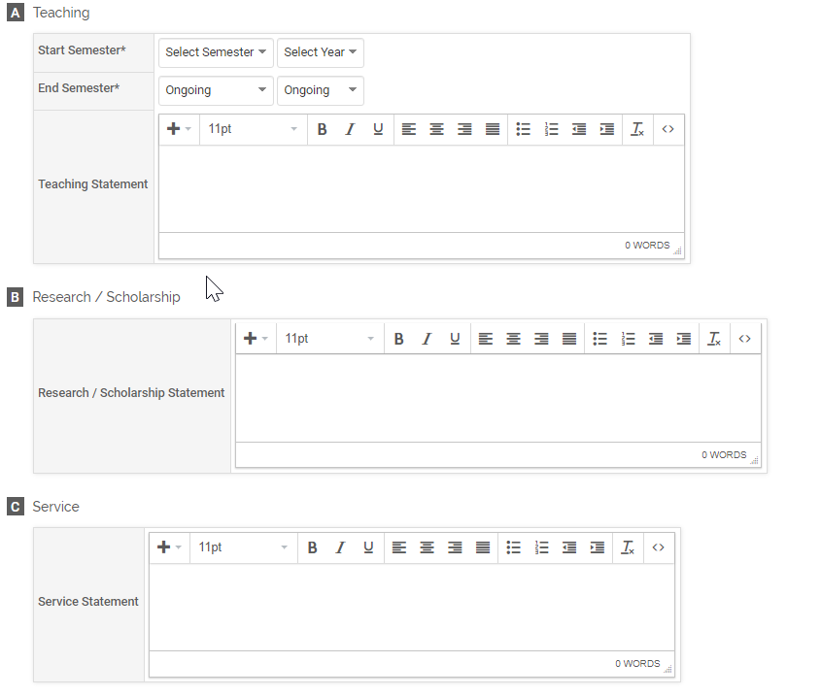

Vitas & Biosketches
The Vitas & Biosketches feature in ClarkEfolio allows a software administrator to create institutional vita templates for various purposes. Faculty members also have the option to create a personal vita template or a biosketch from pre-designed templates to support applications for grants/contracts, including the NIH, NSF, and USDA. In addition, generic templates can be created for other agencies.
HOW TO RETRIEVE YOUR CV?
In order to retrieve a copy of your CV, please select the “Vitas & Biosketches” option on the left-hand side. You will be re-directed to a new page and you will see a list of different CV options as pictured below. Select the desired CV by clicking on the “view” icon. A new screen will appear.

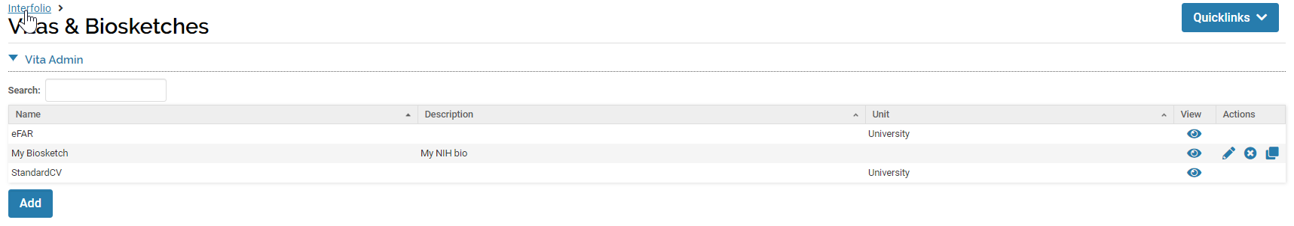
Be aware of the “Date Range” option. You can change the CV to include all your information by selecting the “All” button. Press the “Refresh Vita” button to ensure the information for the date range you are requesting appears. You can also select a specific time frame.
If you want to see how your FAR will look, choose the eFAR type, and then specify the terms/year and then click “Refresh Vita.” Scroll down to see your eFAR.
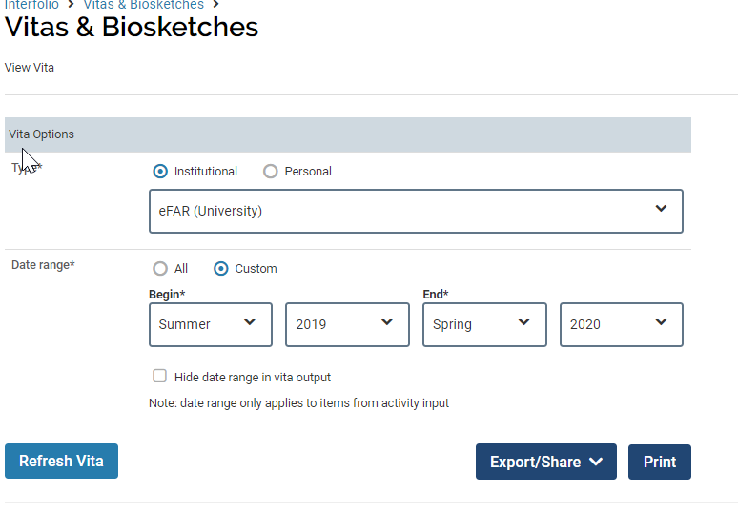

To export your CV or eFAR, click on the “Export/Share” button. You can export your CV as a word document or PDF. You also have the option to share your CV with others by clicking on the “Web Link” option.
Also available is the option to “Print.”
How to Find Colleagues in ClarkEfolio

FIND COLLEAGUES
You may use the “Find Colleagues” section to look for other faculty with similar interests. Under this section, you can search for faculty members who have worked or are working on a certain subject. This may become a powerful tool for Clark once we have more faculty data entered. The data pulled for this section comes from the “Interests in teaching, research and service” section, located in Profile. (See above.)
If you are interested in learning about a new subject and want to get in contact with other faculty who have shown interest on such subject before, you can find them in this section.
