Instructions to Departments for submitting electronic “binders” for COP to review
Note: All binders should be saved as one continuous pdf file, with pages numbered and a table of contents at the beginning.
PDFs can be uploaded to ClarkeFolio by following these directions.
If you run into problems, email Amy Lee, amylee@clarku.edu.

- Departments will get an email when a case has been created for their faculty member. When the department is ready to upload the pdf of the “binder” they can click on “review candidate” in the email to go to ClarkeFolio.

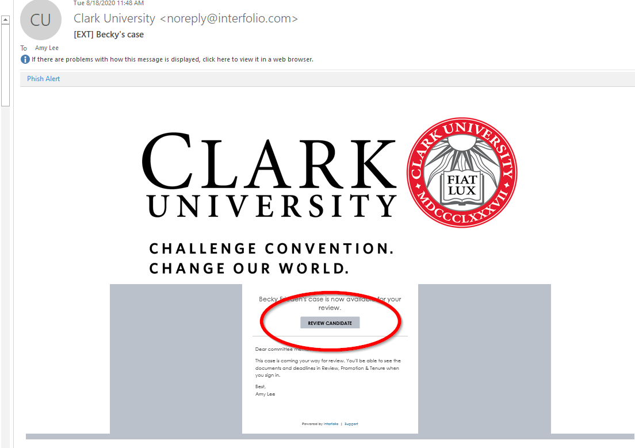

- Once in ClarkeFolio, the department admin will see a screen that looks like this. To access the case, click on “cases” OR just click on the person’s name in your “my tasks” section.
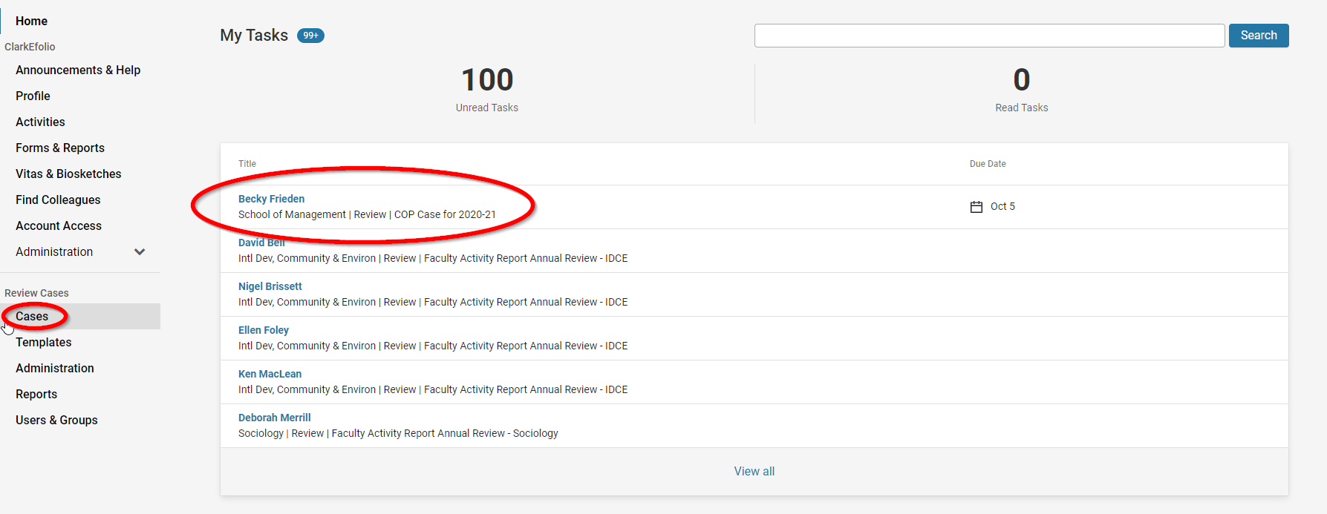

- Once you click into the case, your screen will look like this. If you scroll down to the “Internal Sections” section you will see “Candidate Binder.” On the right, there’s a button for “Add file.”
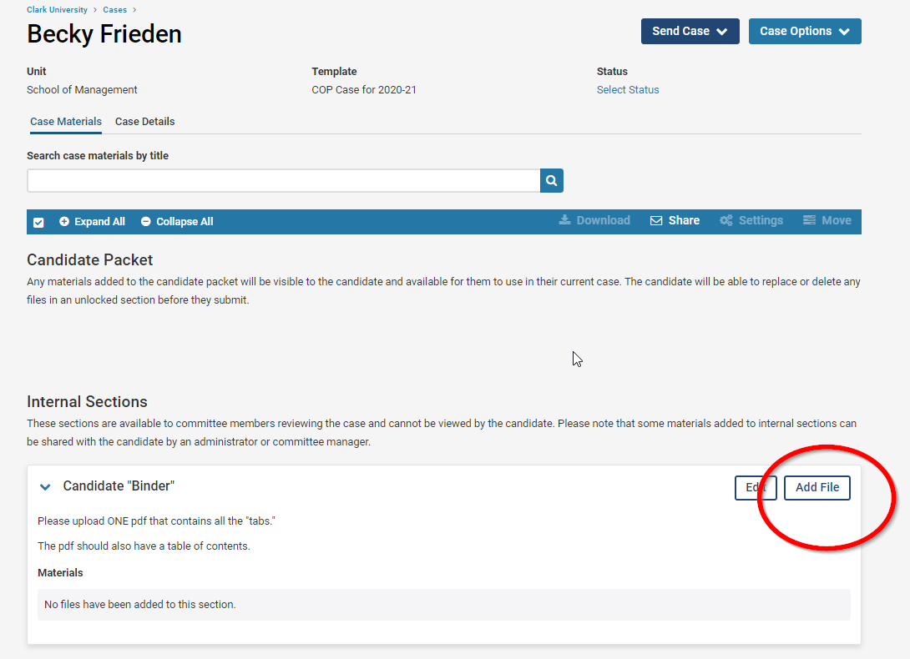

Once you click that button, you will be able to browse your computer to find the pdf file that you’ve created. Once you upload your file, click save.
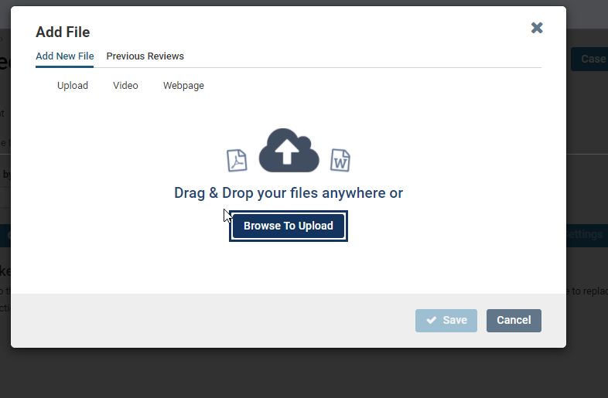

Then, you will be able to see the file that you uploaded.
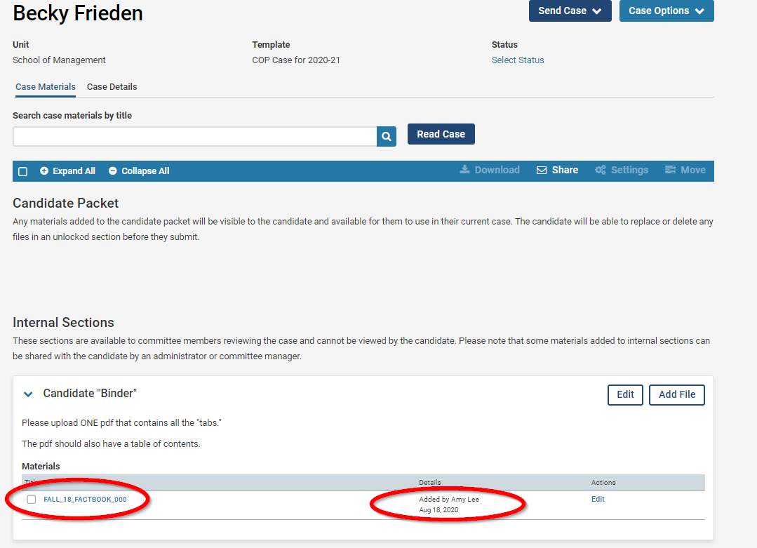

- Once you’ve uploaded your file, click the blue “Send Case” button and choose COP Committee Review. An email dialogue box will appear. Please use the subject line to indicate the Type of Case (Post tenure review, Reappointment, Tenure and Promotion, or Promotion) and the name of the faculty member, and then click Continue.

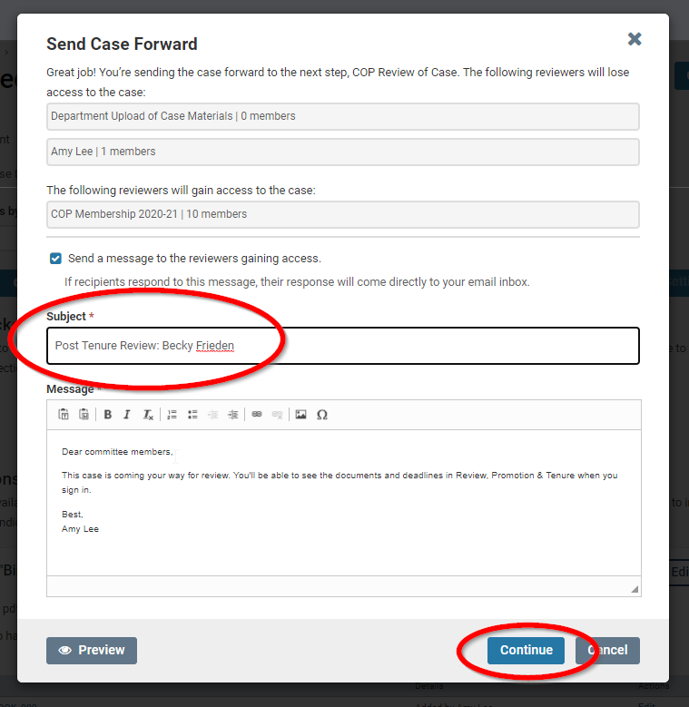

- And you’re all done! Easy peasy!

