Directions for Department Reviewers of Faculty (Chairs and other designated reviewers) in ClarkEfolio
Revised 5/6/2020 by Amy Lee

- Log in to ClarkEfolio
https://www.clarku.edu/offices/academic-affairs/clarkefolio
Click on a faculty member to enter into his/her “case”.
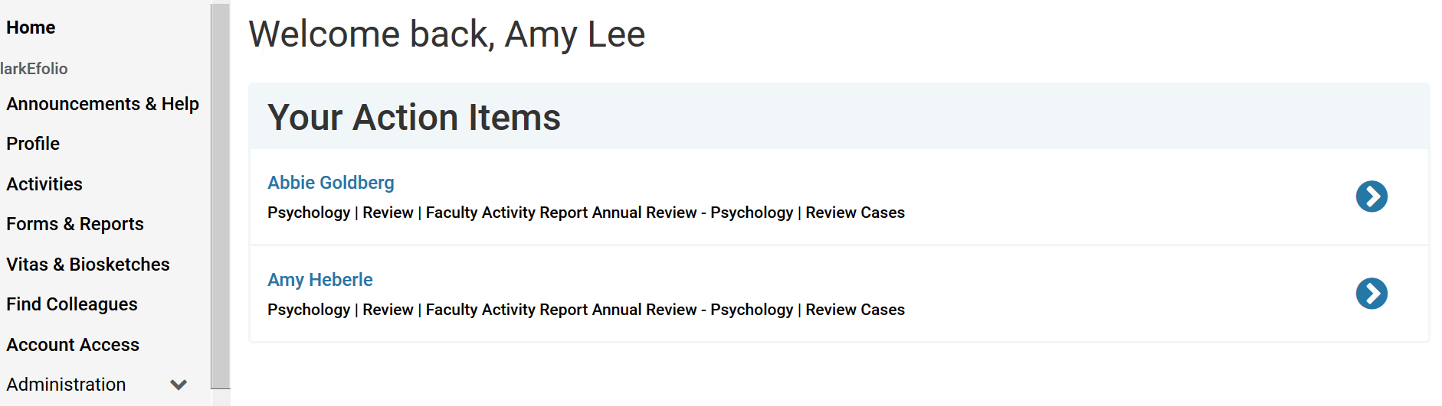

- Upload UWTE reports
Department Admins can scroll down to the bottom of this page to “Internal Sections” and add the UWTE reports. Click “add file” and choose the UWTE reports (Individual Instructor Reports) that have been downloaded to your fileshare or computer.
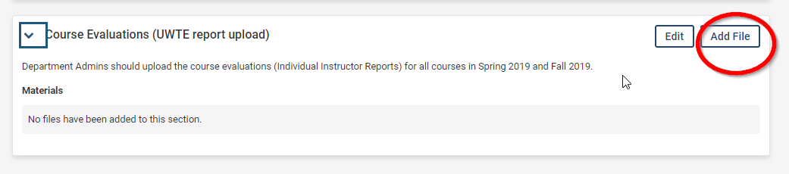
3. Review the case materials
Department Chairs or Faculty Reviewers can click on “Read Case” to see the eFAR, UWTEs, CVs and other attachments. After you’re done, click “return to case.”
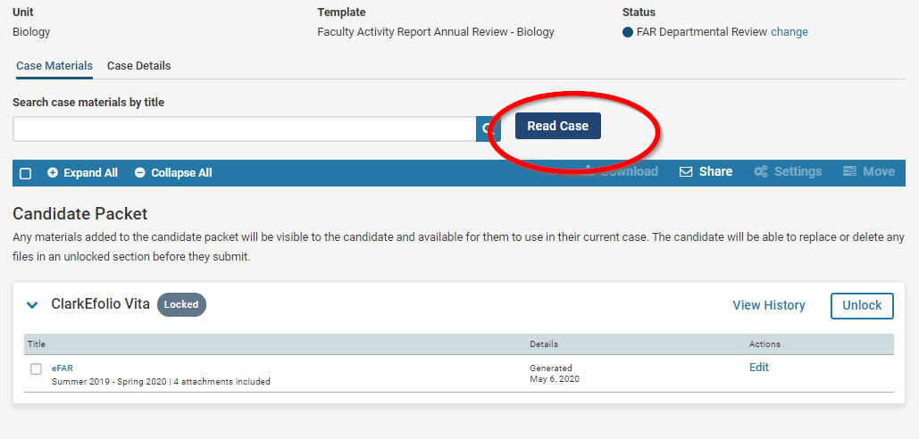
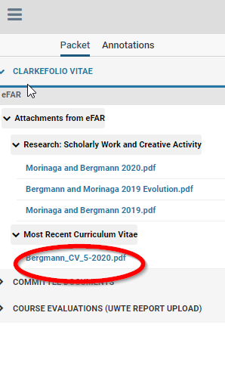

4. Fill out the Review Form
The reviewer should click on the “Case Details” tab and then under Required Items, click “Fill out Form.”
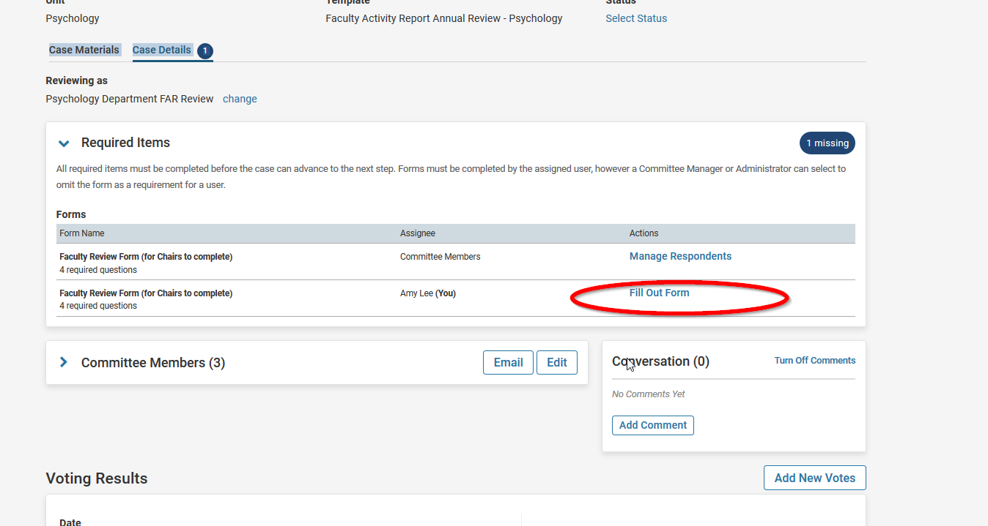

Fill out the form and click “Submit Form” at the bottom of the page. (Faculty reviewing chairs will have a slightly different form.)
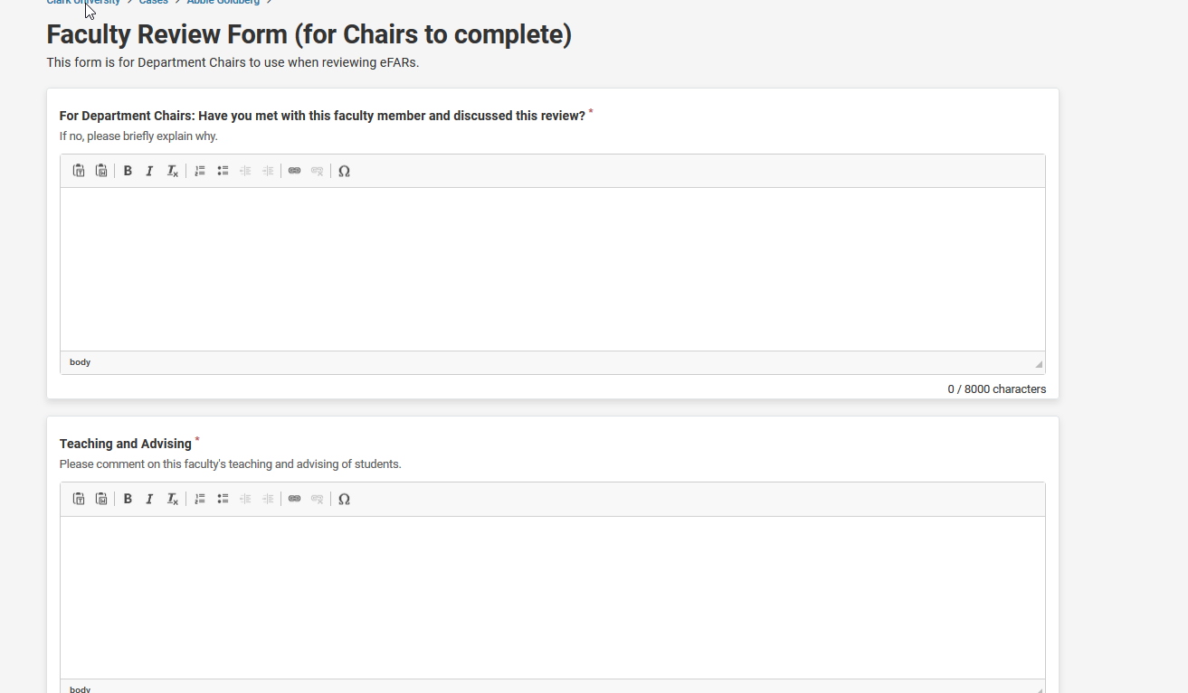

5. Optional: Download Review Form and send to Candidate (the faculty member)
Reviewers can choose to download a pdf of the form and send it to the candidate. First, click the checkbox next to the form, and then choose “Download.” You will get an email with a link to download your pdf.
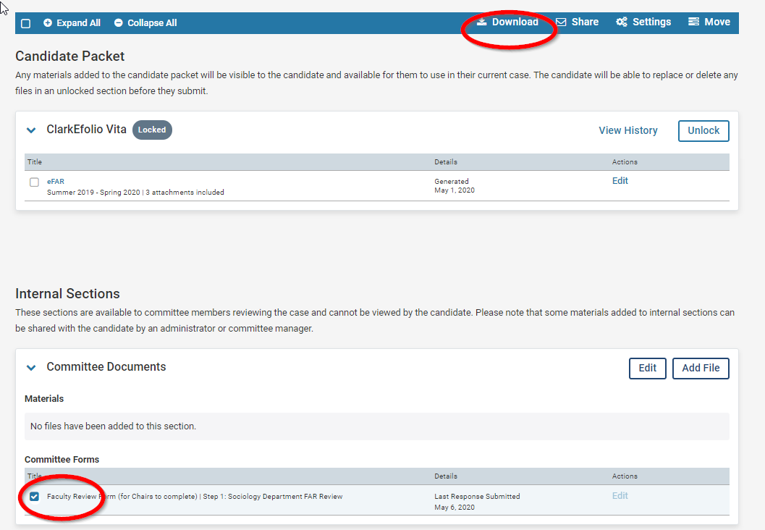

6. Edit your review, if necessary.
If you wish to make changes to the form you submitted, you can do so.
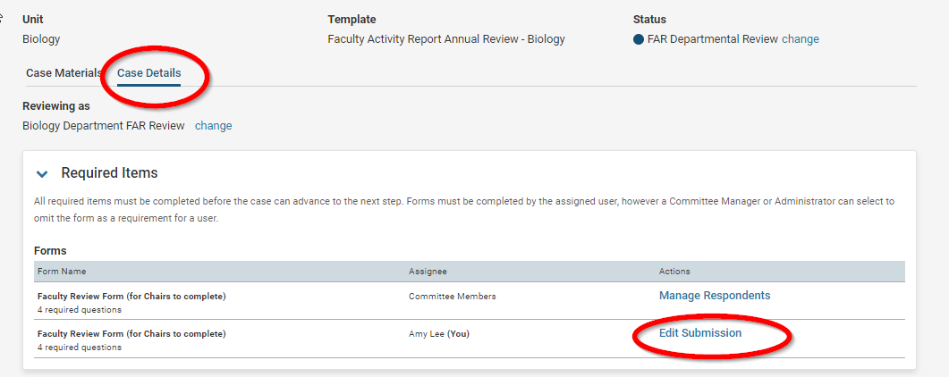

7. Send forward to Provost
Once all your cases have been reviewed, send your cases forward to the next step: Provost Review.