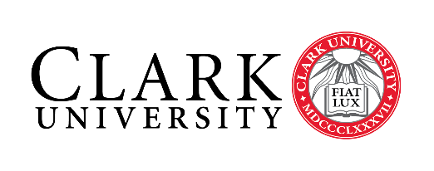

INSTRUCTIONS FOR OBTAINING PRE-APPROVAL FOR COURSES TAKEN
ON A STUDY ABROAD AND AWAY PROGRAM

Please complete this form together with your faculty advisor and submit as part of your application.

1. Select the courses you wish to take during your program
- Courses are not guaranteed to run each semester for some programs, so it is wise to have back-up courses pre-approved.

2. Fill in your course selections and number of credits you will earn for each course
- Remember that you are looking for the appropriate number of credits and NOT number of courses.
- Students should take the equivalent of 3.75- 4.5 Units (or 15-18 US credits) per semester. Any overloads must be approved by Academic Advising.
  - One Clark unit is approximately equivalent to 4 US credits, 6-8 ECTS or 15-20 UK credits. These are approximate and you must check with the Office of Study Abroad and Away for how your exact courses will transfer.

3. Major / Minor / Concentration Credits
- Provide this form, along with copies of syllabi for all proposed courses, to the appropriate department administrator if requesting major/minor/concentration approval.

4. Program of Liberal Studies (PLS) Credits
- If you wish courses to be evaluated for a Program of Liberal Studies requirement, write the requirement for which you want the course considered (i.e. HP, SP, etc.), in the column marked “PLS Requested”. You must receive PLS approval from Dean DeMoura in the Dean of the College office. Please include a course description / syllabi with your request.

5. Faculty Advisor Approval
- This form MUST be signed by your faculty advisor(s), indicating their approval of participation in your selected program, even if you are not requesting major credit.

NOTE: Once your program begins, you MUST email your faculty advisor at Clark and the Study Abroad and Away Office with any course changes. Save your academic-related correspondence and work performed while away. This is important in case there are questions on grading or academic integrity.

- Clark-Approved Programs: Courses taken on a Clark-approved program must be taken for a letter grade. Internship programs must be taken Pass/Fail.

- Non-Clark and Summer programs: All students on a non-Clark program will receive transfer credit provided a C or above is earned.

CLARK STUDY ABROAD AND AWAY COURSE/CREDIT APPROVAL FORM

This form MUST be signed by your primary major faculty advisor(s), indicating their approval of participation in your selected program, even if you are not requesting major credit.

Name______________________________________________ ID#_________________________

Study Abroad Program__________________________________________________ Semester Away: _______________________

Major 1__________________________________________________ Faculty Advisor 1_________________________________

Major 2__________________________________________________ Faculty Advisor 2_________________________________

Minor / Concentration _____________________________________ Faculty Advisor ___________________________________

Course Title | # of host credits | # of Clark units | Major / Minor Approval  (Faculty Initial) | PLS waiver Requested | PLS Approval  (Dean Initial)

I do not plan to receive major or minor credit during my time abroad

Faculty Approval:
I have met with the abovementioned student and confirm that they are on track to complete all academic requirements, based on their completed coursework and proposed courses during their study abroad / away program.

Signature, Faculty Advisor 1, Major (Required) Date

Printed Name and Department

Signature, Faculty Advisor 2, Major / Minor / Concentration Date

Printed Name and Department

Please contact the Study Abroad and Away Office at 508-793-7363 or studyabroad@clarku.edu with any additional questions or concerns.

