How To Open Public Folders In Outlook 2011 For Mac
Article ID: 2220 Last updated on 2/3/2015 4:20:54 AM Product: Exchange
Tags: Outlook, in, for, mac, 2011, public, Folders, open
- In Outlook 2011 for Mac, in the ribbon, select Tools tab, then click on Public Folders.
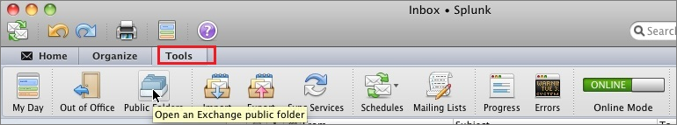

- In Folder Browser window, navigate through the public folders tree until you locate the folder you need to access. Highlight the public folder, then click on Subscribe. Once you have selected all the folders you need, close the window. Note: You will need to individually subscribe to each public folder you need to access.
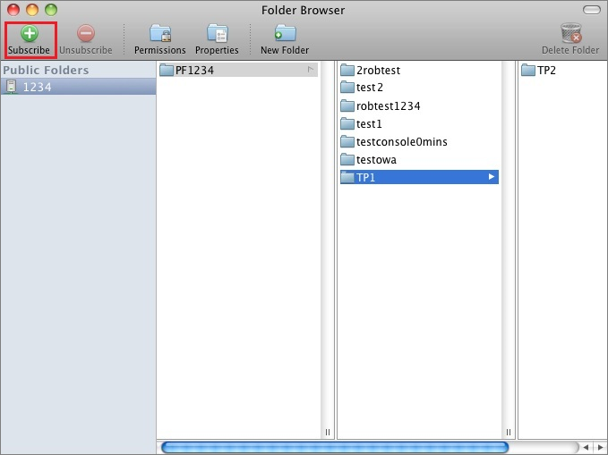
- Open Mail in your Outlook 2011 for Mac. Under the Subscribed Public Folders you will see the list of public folder you subscribed to.
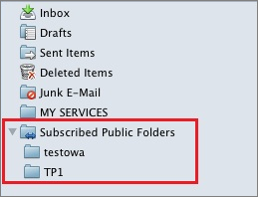

Other Notes:

      - If you see the e-mail sender listed as KKEEVAN, that means we have received either a paper application or direct e-mail, and Kelly Keevan has scanned the material into the file. The applicant’s name will appear in the subject column.

      - Only members of the search committee, the respective VP/Dean and HR staff have access to this folder.

      - HR will acknowledge receipt of each application directly to the applicant.

Please contact HR at X7294 if you have any problems accessing this folder or wish us to include others on your search committee.

